Using Linux terminal commands (uname, Iscpu, lsblk, ps, top), investigate the relationship between hardware resources and operating system services. Prepare a report explaining how the OS abstracts CPU, memory, storage, and I/O devices.

Output:
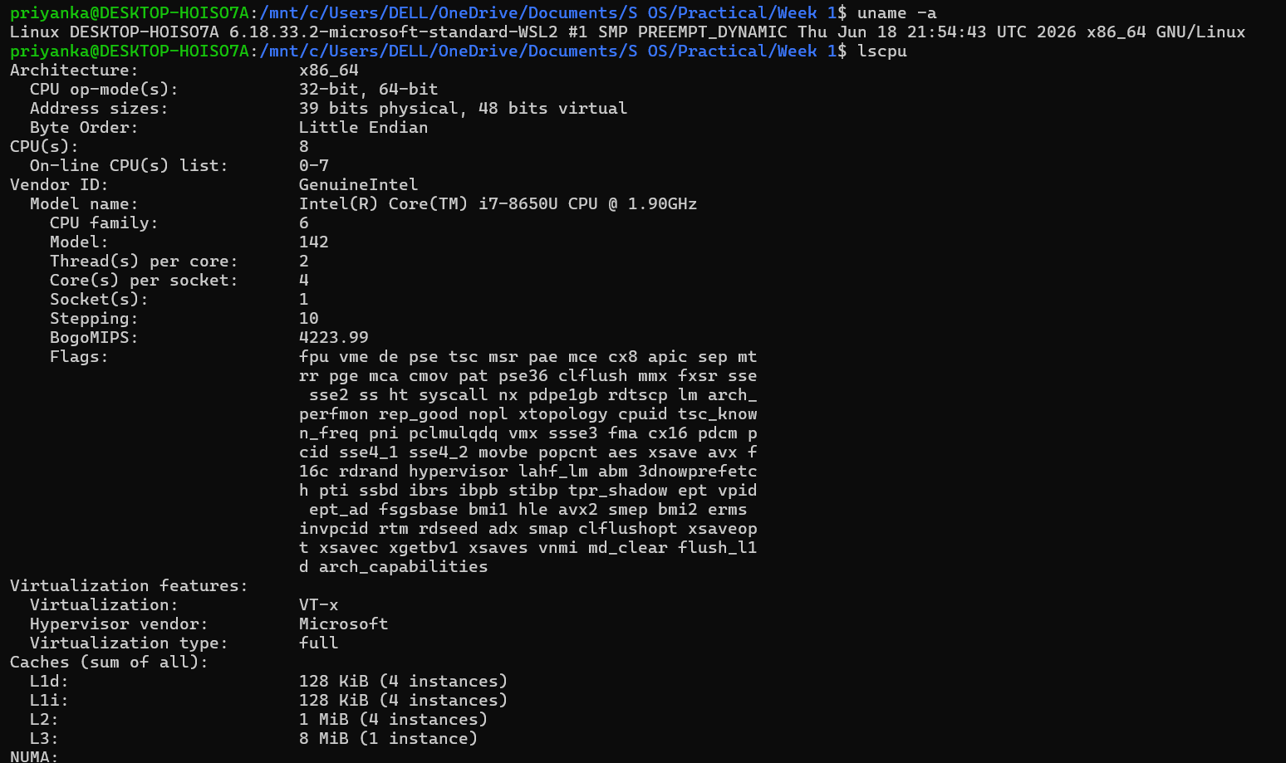
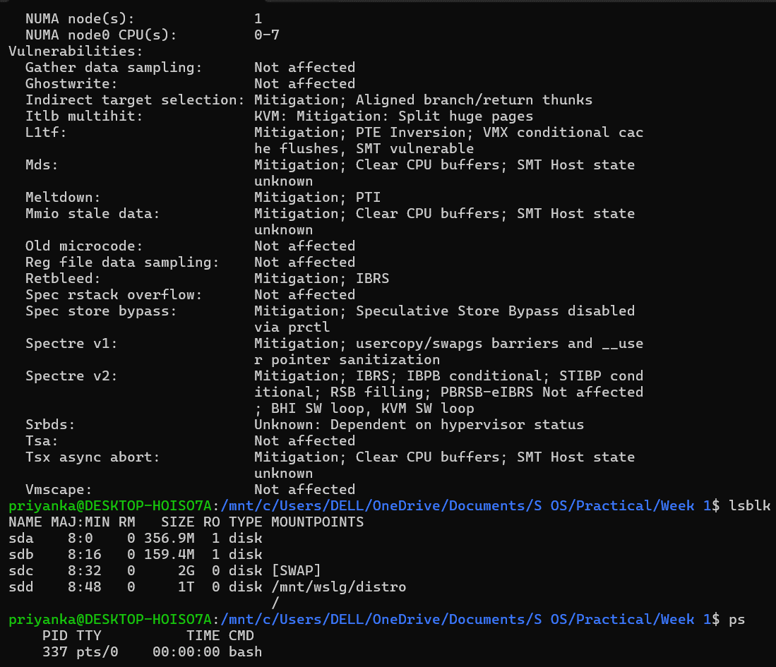
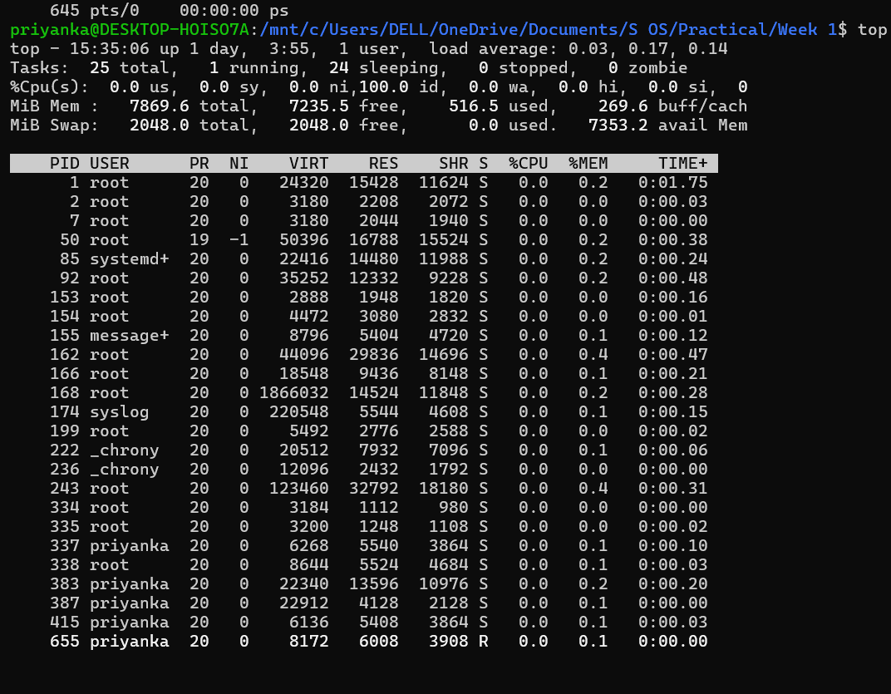
The Linux operating system acts as an interface between applications and hardware. Commands such as lscpu, lsblk, ps and top allow users to observe CPU, storage, and process information without directly interacting with the hardware. The kernel manages these resources and provides abstractions such as processes, files, memory, and device interfaces, making hardware easier and safer for applications to use.

